

SCHOOL OF INFORMATICS & IT

Part 1: Project Proposal

Student Name (Matric Number) : Ho Chern Tung

Tutorial Group : PC08
Jenny LING (TP)
Tutor : Kent Tan

Submission Date : 23/5/2026

Declaration of Originality

I am the originator of this work and I have appropriately acknowledged all other original sources used as my references for this work.

I understand that Plagiarism is the act of taking and using the whole or any part of another person’s work, including work generated by AI, and presenting it as my own.

I understand that Plagiarism is an academic offence
and if I am found to have committed or abetted the offence of plagiarism in relation to this submitted work, disciplinary action will be enforced.

Declaration on the use of Generative AI tools for assignments

Describe how you have used Generative AI tools such as ChatGPT or Dall.E-2 in your assignment.

Show snapshots of the conversations with the AI tool (i.e., the prompts you used and the response you get from the AI tool).

Used OpenArt and Stitch for generation of design concepts.

How do you indicate the reference?
The content generated by AI tools are not retrievable except by the user who generated them, so they are considered non-recoverable sources. Although non-recoverable data or quotations in APA Style papers are usually cited as personal communications, with ChatGPT-generated text there is no person communicating. Quoting text from ChatGPT chat is therefore more like sharing the output of an algorithm, with a reference list entry and the corresponding in-text citation.

According to the official APA Style site, ChatGPT references should be cited as:

E.g. OpenAI. (2023). ChatGPT (Sep 25 version) [Large language model].
https://chat.openai.com/chat

Important Note:

- Do not copy answers produced by the AI tool in totality as it is considered as plagiarism.

- Do not rely on any information produced by the AI tool blindly. You should always verify the answer with other sources. Do not assume that these answers provided by the AI tool are correct.

To achieve quality outputs from the AI tool, you should provide good prompt that is clear and specific. Be precise and provide context. Avoid asking open-ended questions.


School of Informatics & IT

Mobile App Development (CIT2C18)

AY 26/27 Apr Semester

Project Proposal

(Part 1)

Table of Contents
Application Description 5
Database Design 6
Design Analysis and Wireframe 7
Widget Tree 8
Additional Features 9
References 10

The yellow text in each section is provided as a guide. Please make sure to REMOVE them before submitting your work.

Application Description
Application Name | FoodRescue
Target Audience | Eco-conscious consumers, budget-conscious individuals (such as students and young professionals), and daily commuters in Singapore looking to rescue high-quality surplus food from local merchants, bakeries, and grocers before closing time, instead of letting them go to waste.
Authentication Features | Firebase Email/Password sign-in with "Forgot Password" flow.  Google Sign-In integration to provide a seamless, one-tap onboarding experience.
CRUD-related Features | Create: A new reservation record will be created when a user reserves an item by specifying details such as the quantity and scheduled pickup time.  Read: Users can check their ongoing reservations, or past reservations via the reservations screen. The user will also be able to view each reservation in detail.  Update: Users can modify details such as the quantity and timing for each reservation.  Delete: Users can cancel a pending reservation if they wish to.
Applied AI Feature | When a collection has been confirmed, the ai will automatically run an evaluation to determine the environmental footprint of the user’s reservation (e.g. water saved). The ai will dynamically compute the exact ecological footprint adjustments and then send a user’s personalised metrics for each collected reservation, which will instantly populate the user's Sustainability & Impact Dashboard.
Suitable NETS QR Payment Scenario | Once a user reserves a bag, they will be brought to an "Order Confirmation" page. Upon arriving at the store or pickup location, they just need to scan the NETS QR code generated for payment. After scanning, the app will update the order status to "Collected."

Database Design

ER Diagram
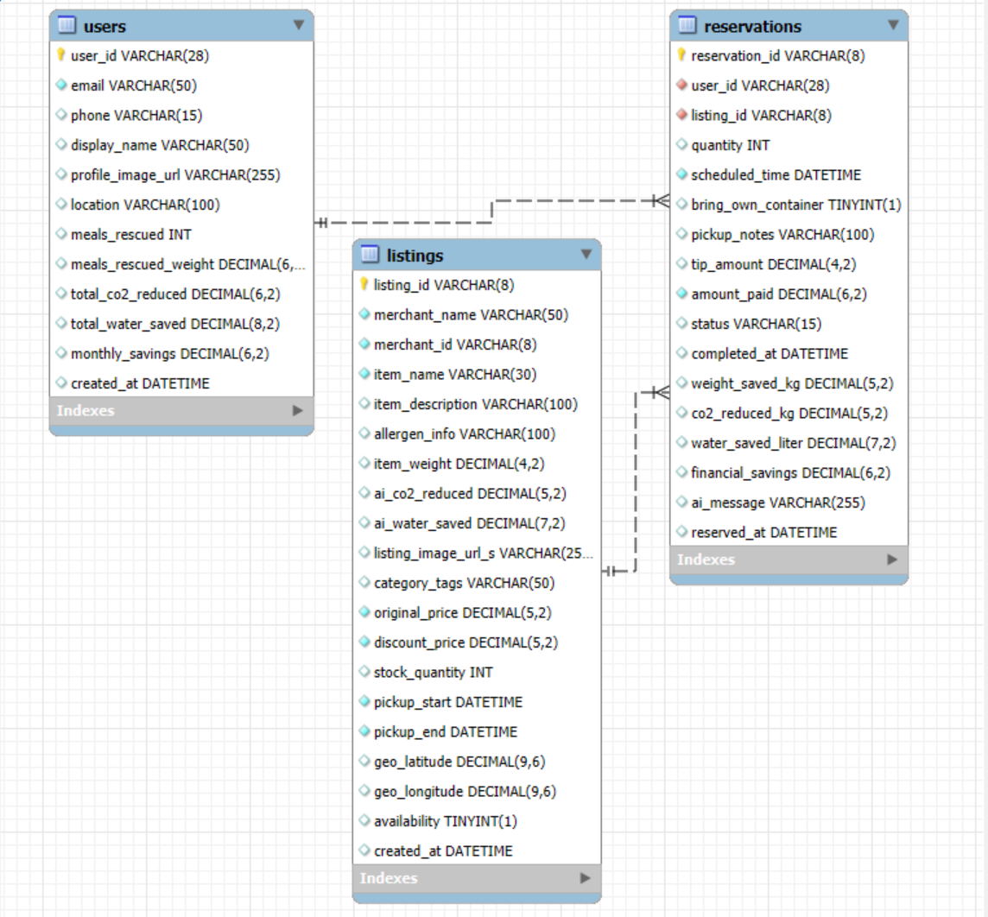

Data dictionary:

Field Name | Data Type | Field Size | Primary/ Foreign key | Description | Example
user_id | String | 28 | Primary key | Unique ID for each user | Wj39Fk20Lsn98Pqm102938kl
email | String | 50 | - | User's registered email address | user@example.com
phone | String | 15 | - | User's mobile contact number | +6591234567
display_name | Varchar2 | 50 | - | Public name displayed in the app | John Doe
profile_image_url | String | 255 | - | Cloud storage link to profile photo | https://storage.url/p1.jpg
location | String | 100 | - | Default location address of user | 45 Chancery Lane Singapore 309568
meals_rescued | Integer | - | - | Total count of surplus meals rescued | 14
meals_rescued_weight | Float | - | - | Total weight of food saved in kg | 5.60
total_co2_reduced | Float | - | - | Lifetime carbon footprint reduction | 2.00
total_water_saved | Float | - | - | Lifetime water footprint offset in Litres | 10.00
monthly_savings | Float | - | - | Total financial savings this month | 84.50
created_at | Date/Time | - | - | Date and time account was created | 05/05/2026 14:30:00
(Table: Users)

(Table: Listings)
Field Name | Data Type | Field Size | Primary/ Foreign key | Description | Example
listing_id | String | 8 | Primary key | Unique identifier for surplus item | LST00001
merchant_name | Varchar2 | 50 | - | Name of the selling store or bakery | The Daily Crumb
merchant_id | String | 8 | Foreign key | Links to internal merchant registry | MER10001
item_name | Varchar2 | 30 | - | Name of the surplus food product | Surprise Bread Box
item_description | Varchar2 | 100 | - | Summary details of listing contents | May include sourdough or tarts
allergen_info | Varchar2 | 100 | - | Allergen and dietary flags | Contains nuts, dairy
item_weight | Float | - | - | Estimated weight of listing unit | 0.45
ai_co2_reduced | Float | - | - | Estimated carbon reduction in kg | 0.12
ai_water_saved | Float | - | - | Estimated water savings in litres | 1.50
listing_image_url_s | String | 255 | - | Storage link to listing thumbnail image | https://storage.url/l1.jpg
category_tags | Varchar2 | 50 | - | Grouping keywords for marketplace filter | Bakery, Halal
original_price | Float | - | - | Original retail price before discount | 15.00
discount_price | Float | - | - | Discounted price paid by app user | 5.50
stock_quantity | Integer | - | - | Number of units currently available | 5
pickup_start | Date/Time | - | - | Beginning of collection time window | 05/05/2026 18:00:00
pickup_end | Date/Time | - | - | Expiry of collection time window | 05/05/2026 20:00:00
geo_latitude | Float | - | - | Map coordinates for store / pickup location pin | 1.352083
geo_longitude | Float | - | - | Map coordinates for store / pickup location pin | 103.819836
availability? | Boolean | - | - | True/False flag checking stock availability | true
created_at | Date/Time | - | - | Time stamp of offer publication | 05/05/2026 12:00:00

(Table: Reservations)
Field Name | Data Type | Field Size | Primary/ Foreign key | Description | Example
reservation_id | String | 8 | Primary key | Unique identifier for booking ticket | RES00001
user_id | String | 28 | Foreign key | Link to user profile making reservation | Wj39Fk20Lsn98Pqm102938kl
listing_id | String | 8 | Foreign key | Link to listing bundle being claimed | LST00001
quantity | Integer | - | - | Number of items reserved | 2
scheduled_time | Date/Time | - | - | Expected time window selected for pickup | 05/05/2026 18:30:00
bring_own_container | Boolean | - | - | True/False indicator for container incentive | true
pickup_notes | Varchar2 | 100 | - | User-side notes for pickup staff | Will arrive late near closing
tip_amount | Float | - | - | Voluntary micro-tip added at checkout | 1.00
amount_paid | Float | - | - | Total final payment transacted | 12.00
status | Varchar2 | 15 | - | Transaction order fulfillment status | Completed
completed_at | Date/Time | - | - | When transaction status shifts to claimed | 05/05/2026 18:42:11
weight_saved_kg | Float | - | - | Dynamic finalized mass rescued | 0.90
co2_reduced_kg | Float | - | - | Gemini calculated final carbon metrics | 0.55
water_saved_liter | Float | - | - | Gemini calculated final water metrics | 3.00
financial_savings | Float | - | - | Exact money saved relative to original retail | 19.00
ai_message | Varchar2 | 255 | - | Dynamic text insight string from Gemini | Your rescue from The Daily Crumb...
reserved_at | Date/Time | - | - | Timestamp when reservation was clicked | 05/05/2026 14:51:34

Design Analysis and Wireframe

Visual Concept 1: Eco Green design
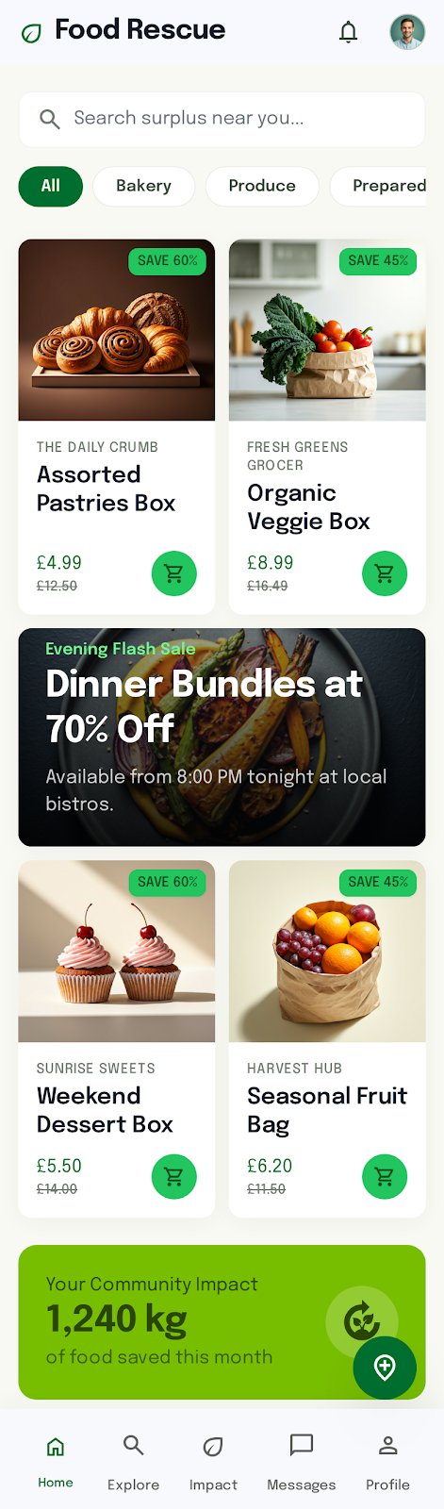
In my first concept, I explored a clean, high-brightness layout featuring a soft cream backdrop and large, rounded product image containers.
This design aligns well with the eco-friendly, sustainable theme of the application. The generous white space gives the interface a premium, trustworthy feel that is highly appealing and accessible.
However, looking at this from a business perspective, the colour green may not stand out enough, therefore I wanted to explore other colour schemes.
Hence, I decided to adopt the general layout for my final design only.

Visual Concept 2: Dark Tech design
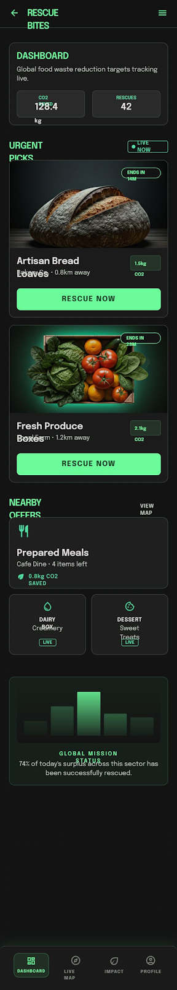
For my second concept, I shifted to a dark-mode theme to see if a data-driven dashboard layout would better emphasise the real-time urgency of food rescue transactions.
Visually, it does an excellent job of highlighting environmental impact data like "Carbon Saved" and creating a psychological sense of excitement.
However, it is impractical for outdoor use under direct sunlight, which is exactly when users will be navigating outside to pick up their food.
Therefore, I rejected the dark theme to preserve day-to-day outdoor usability. However, I loved how the environmental tracker statistics motivated the user to save food, so I decided to rescue the dashboard counter metrics and use them in the Impact Dashboard screen.

Visual Concept 3: Stand-out Yellow design
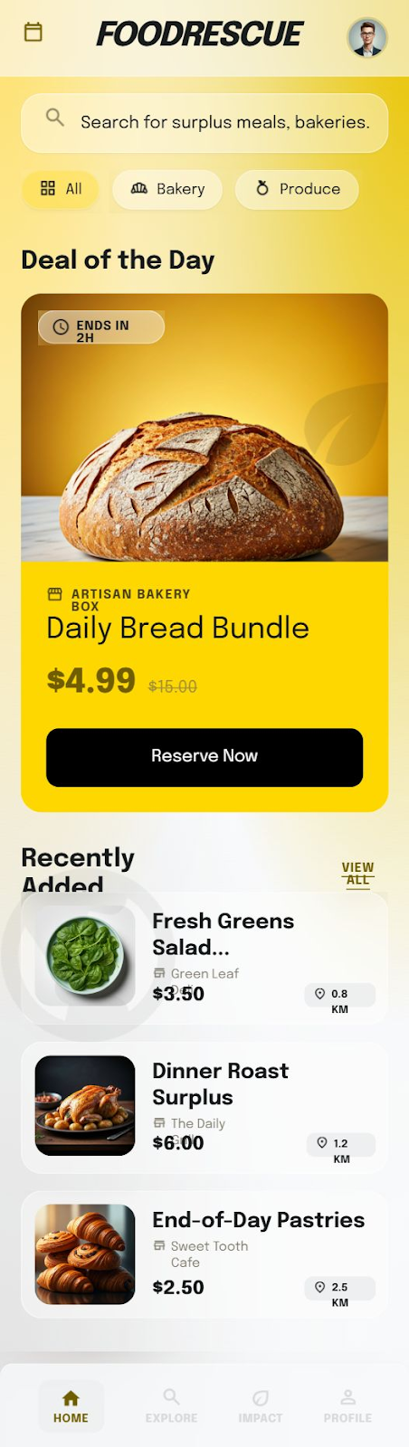
In my third concept, I looked for a middle ground that focused on clean organisation, simplicity, and a dense text layout. From an aesthetic standpoint, the colour palette generated for this concept was highly polished, offering strong visual hierarchy and a professional, trustworthy theme suitable from an operational business perspective. However, I saw a significant usability flaw where the listed food item images are compressed into a small thumbnail format, making them too small for a mobile consumer to see clearly.
After consideration, I decided to merge the intuitive layout from my first design concept with the refined colour scheme of this third concept to create my final design.

Final Design

Authentication Screens
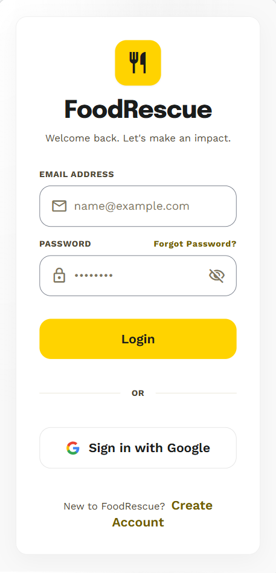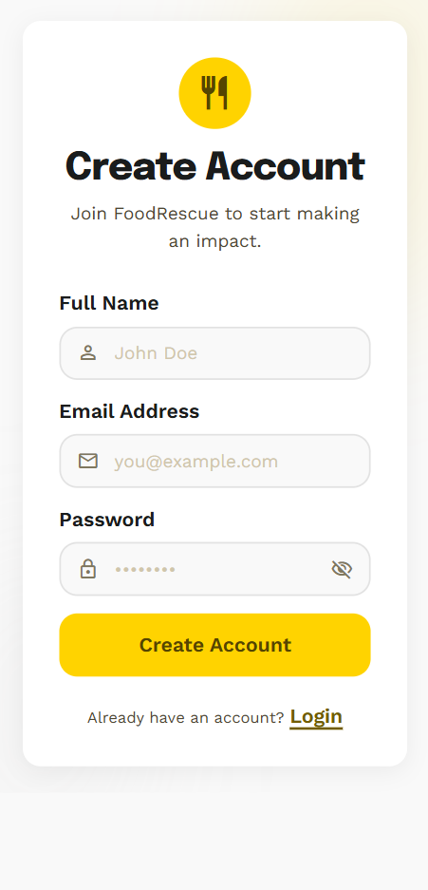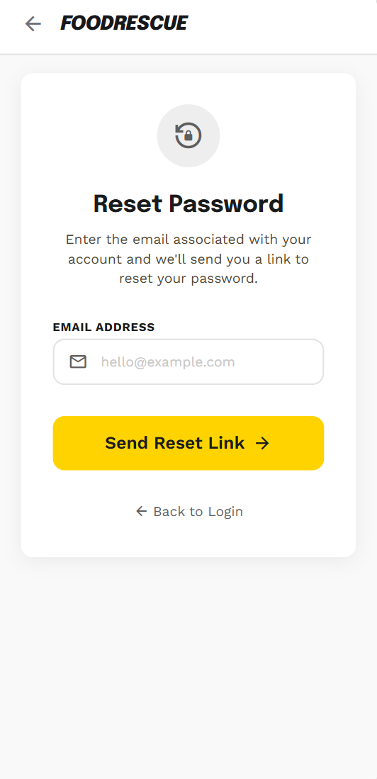

Home Screen (Main Screen) | Explore Discovery-Map Screen
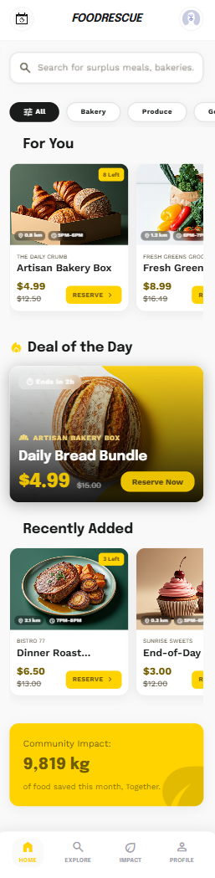 | 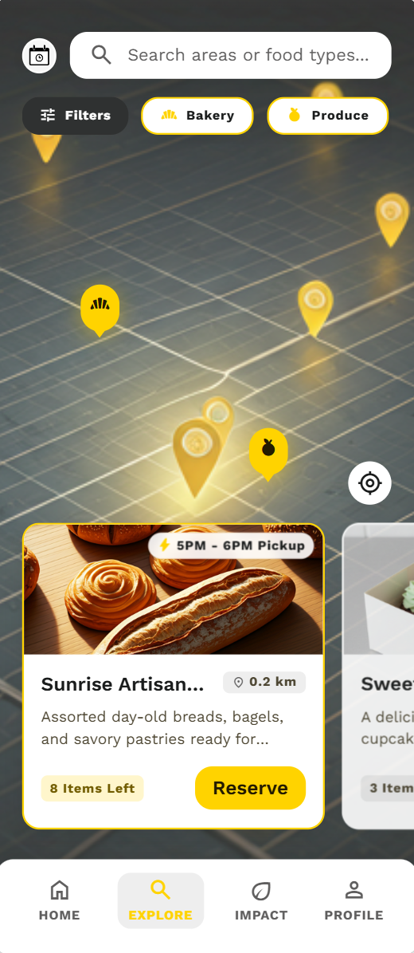

Item Details Screen | Reservation Creation Modal | Reservation Confirmation Screen
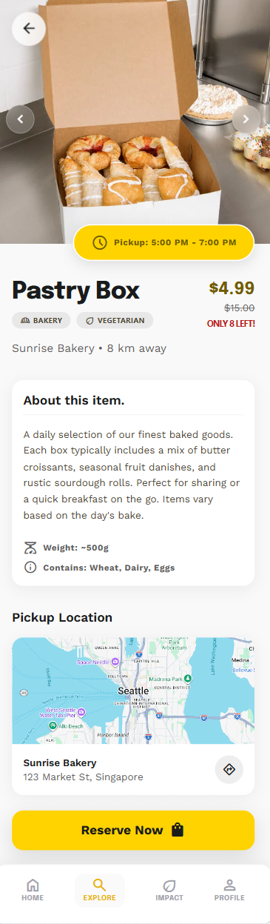 | 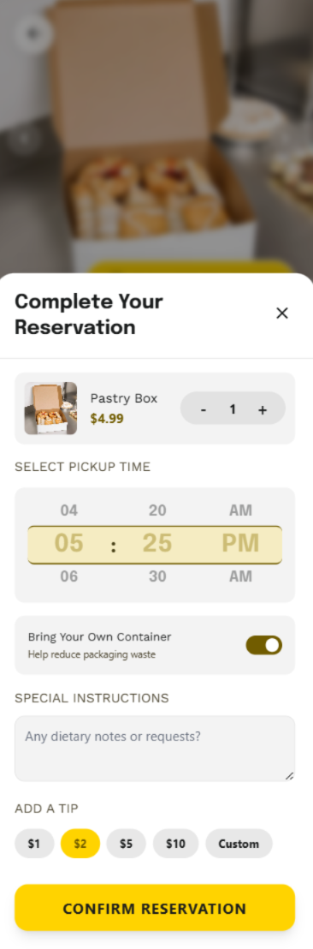 | 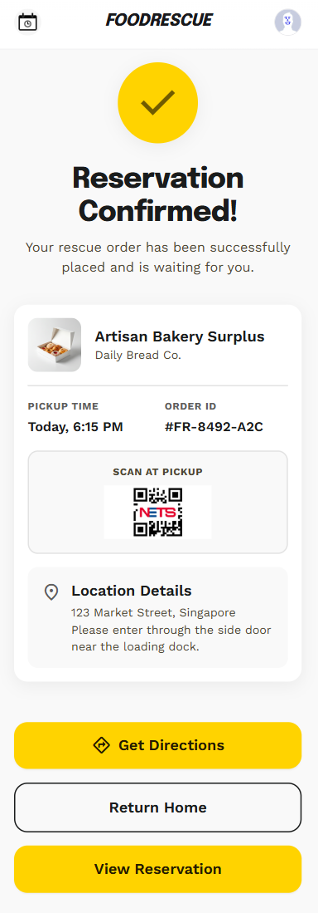

View Reservations Screen | Reservation Details Screen | Update Reservation Modal
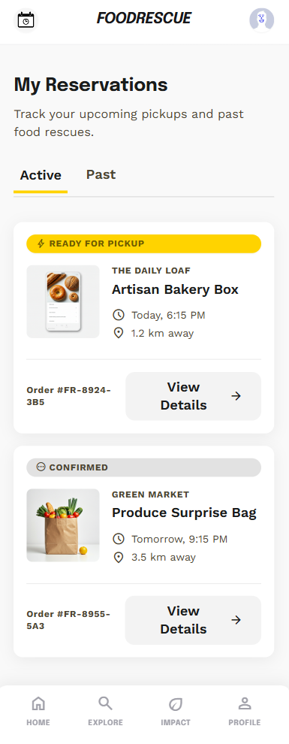 | 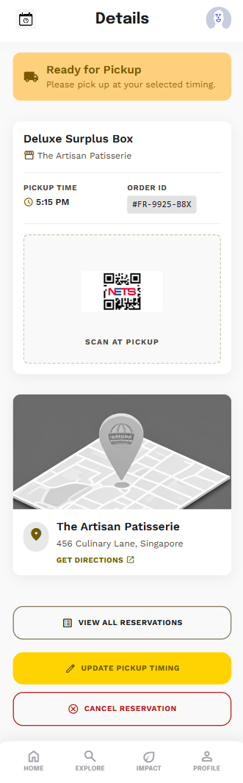 | 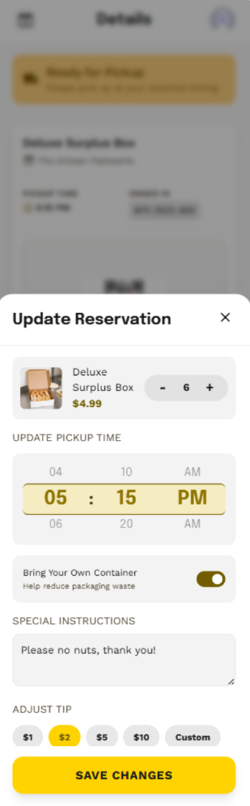

Impact Dashboard Screen | Profile Page Screen
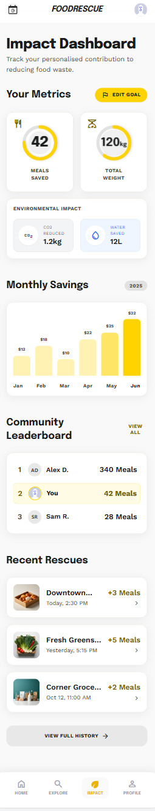 | 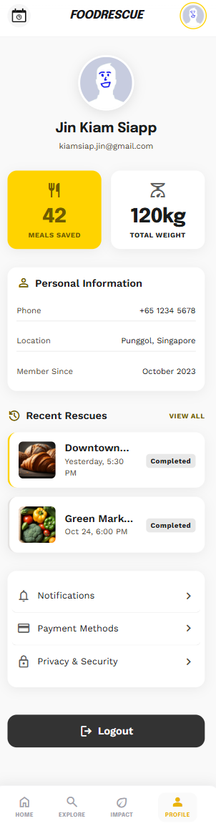

Widget Tree
Wireframe Screenshot (Main Screen)


Widget Tree
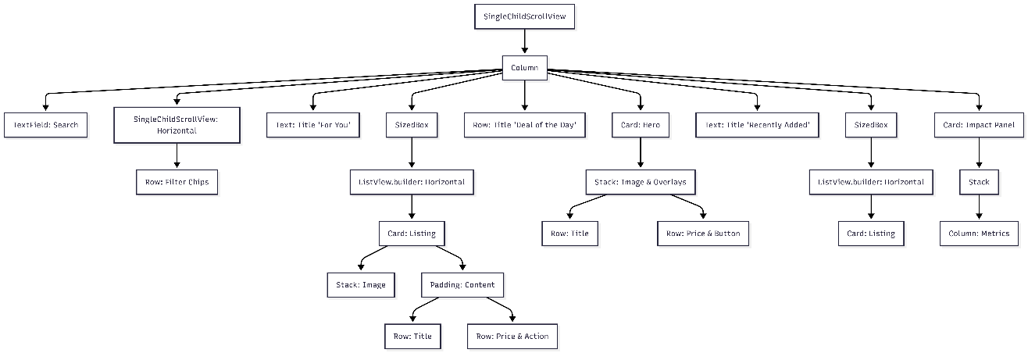

Additional Features

Feature Name | Discovery Map Explorer
Description | This feature provides an interactive, visual map interface that plots nearby food and beverage partner stores based on the user's real-time geographic location. Instead of scrolling through a standard text grid, users can pan and zoom through an integrated map layout populated with custom merchant pins. Selecting a pin will open an overlay preview that shows the items listed in the store, with details such as its distance (from the user’s current location), and a quick-action button to open up a specific listing page.
Purpose / Benefit | It significantly enhances localised store discovery, usability, and user engagement. By contextualising F&B merchants spatially, users can quickly and easily identify how close exactly a store is to their current location or commute route. This convenience will reduce the friction of picking up time-sensitive food bundles, driving spontaneous foot traffic to nearby local businesses and gamifying the exploration of the community.
Integration with Application | The Discovery Map Explorer is seamlessly integrated directly into the global bottom navigation bar as a primary screen and accessed by tapping on the “Explore” button.

References

